PRESS INFO: OVERVIEW OF INTERSOLUTION 2020
Ghent, 21 January 2020

Much attention paid to batteries and smart converters at InterSolution 2020
Over 80 exhibitors present at the international trade fair for solar energy
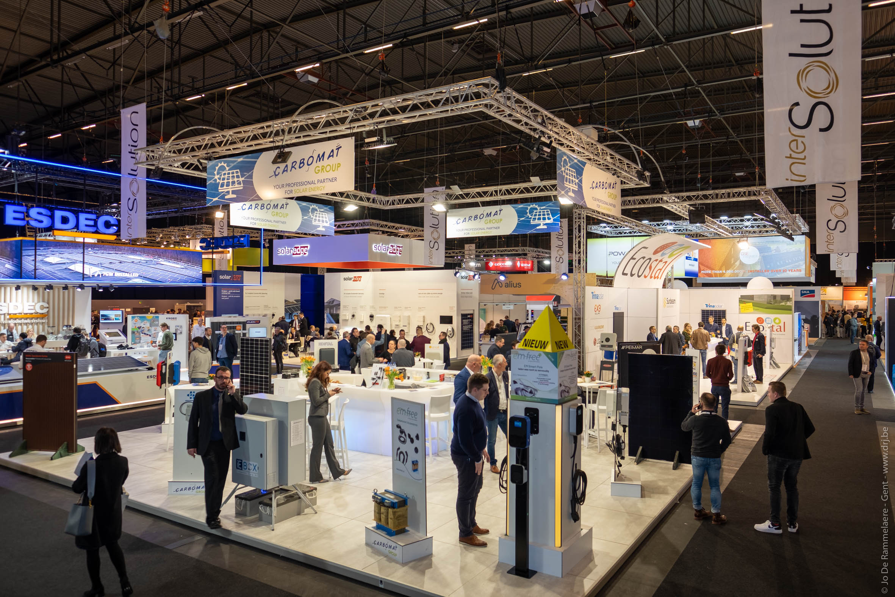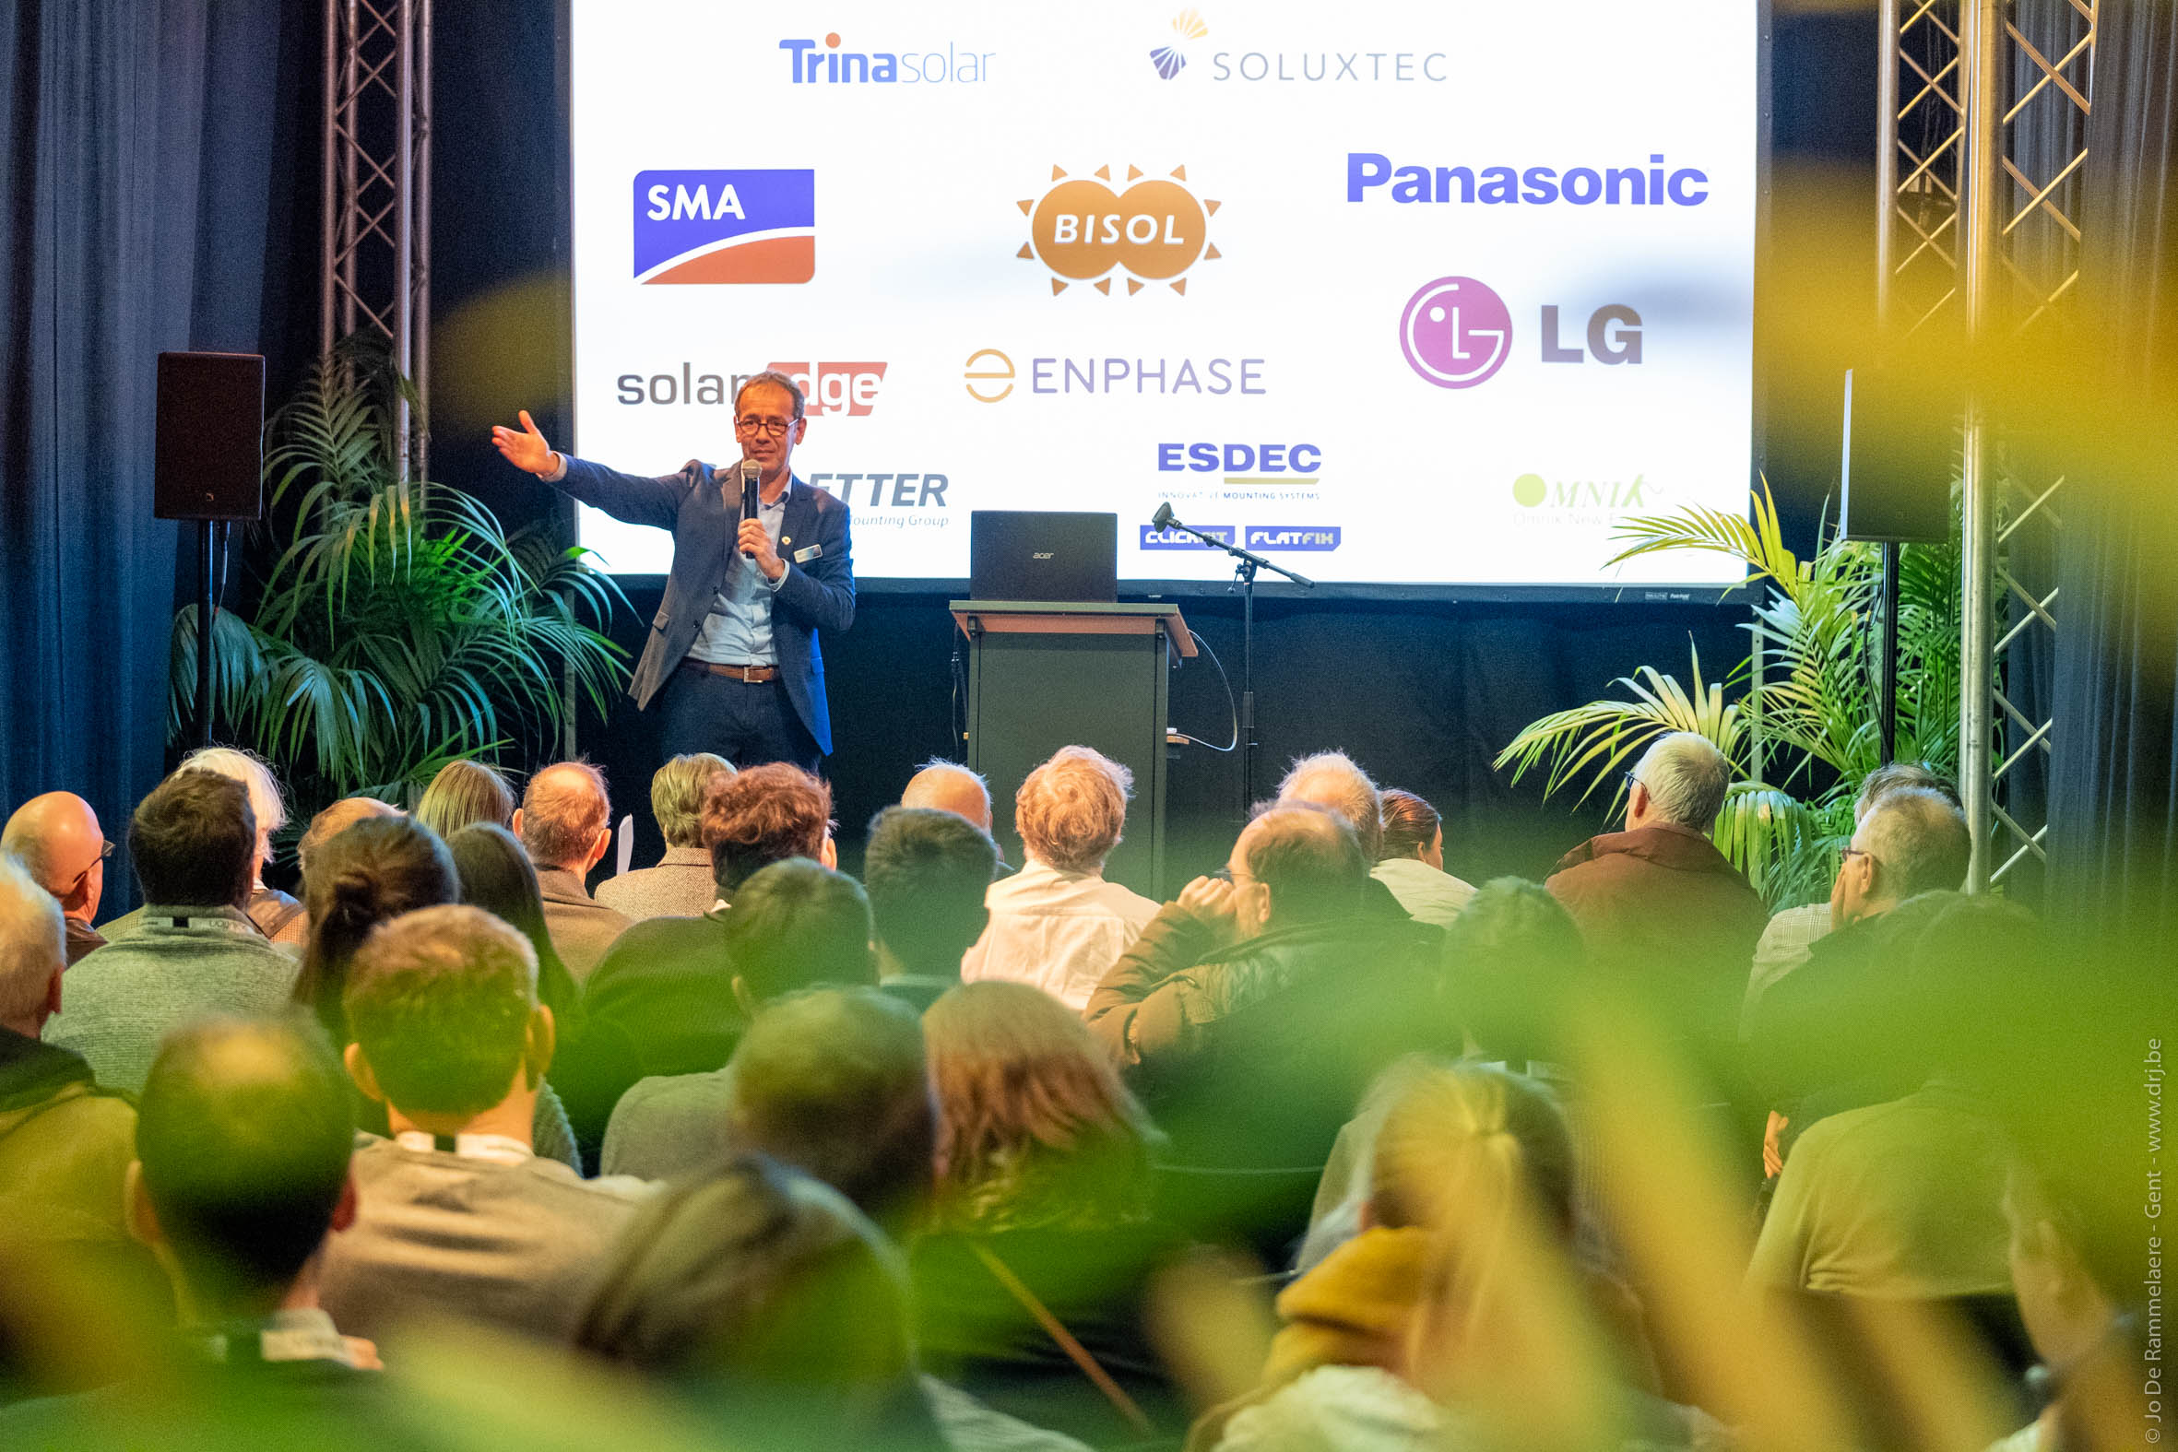
Anyone who visited the 9th edition of InterSolution on 15 and 16 January will have immediately noticed that the solar market is growing and booming. For two days, the entire solar energy market gathered at Flanders Expo in Ghent. Think of suppliers of all types of solar panels, storage systems, converters, assembly systems and related products. More than 80 international exhibitors displayed their very latest innovations in the field of solar panels, energy storage, assembly systems, control techniques and software. In addition, visitors were able to attend various Master Classes.
Never before has there been so much media attention on solar energy, and that attention will certainly only increase in the coming decade. The Netherlands is among the top in the world in 2020, and the Flemish solar energy market could experience a sales boom among consumers this year (because anyone who installs solar panels in 2020 can still enjoy the benefits of the backwards-counting meter). And this revival was clearly tangible at InterSolution, the networking and trade fair for solar energy in the Benelux. No fewer than 2,683 solar professionals (+ 8% compared to last year), 19% of whom came from the Netherlands, visited InterSolution to discover the innovations of leading suppliers from Belgium, the Netherlands, Luxembourg, Germany, France, Austria, Italy, Israel, etc. with their own eyes. “InterSolution 2020 was not only a fascinating edition, with many interesting novelties and scoops, but also a much-visited edition”, says exhibition manager Delphine Martens.
360° image of the solar market
Visitors to the past edition, mainly electricians and solar installers, but also contractors, installers, roofers, plumbers, architects, etc., were given an up-to-date and all-encompassing picture of the offer in the sector. Particularly striking this year was the strong focus on batteries, both for home and industrial applications, and battery storage systems. In addition, exhibitors and visitors paid ever more attention to smart energy management systems and central converters given that solar projects are growing significantly in size. Living comfort, ease of use, self-consumption and energy savings are becoming increasingly important, and hybrid converters are also becoming ever more popular.
Smart apps were presented during InterSolution, providing full support for the installer, from commissioning to monitoring. E-mobility fans got the chance to see how to charge their vehicle using self-generated, cost-efficient solar energy, with the converter for solar panels being combined with the charging point for the car.
New assembly systems were also demonstrated, and here the emphasis is increasingly on a sleek look. The Smartflower is also back, with installation and connection taking just a few hours. Finally, attention was paid to the safety (including fire safety) of PV installations.
Exhibitors in 2020
These were the exhibitors participating in InterSolution 2020: ABB, Accu Viks, AliusEnergy, Astronergy Solar Modules, Avasco Solar, Battery Supplies, Bauer Energiekonzepte, BayWa r.e. Solar Systems, BlueSky Energy, BMP Building Services, Carbomat, Cast4all, Cebeo, Conduct Technical Solutions, Dijkman Elektrotechniek, Ecco Nova, ECO-Tronic, Ecostal, Esdec, ESTG, EV-Box Belux, Fronius International, GPC Europe, GSE Integration, Guangzhou Sanjing Electric Co., Hanover Solar, Huawei Solar, Intermat, Jiangsu GoodWe Power Supply Technology Co., K2 Systems, Krannich Group, Krannich Solar, Mylight Systems, Niko, Ningbo Ginlong Technologies Co., Ningbo Ulica Solar Scie NCE & Technology Co., Normandie Robotique Industrie, Novotegra, Omvormer Service, PergoSlate, Powerdeal, Premium Mounting Technologies, Project Zero, PV Cycle Belgium, PV Vlaanderen / ODE, PVX Multimount, Q-Cells, Rewa, Rexel Belgium, S:FLEX Nederland, Sanutal, Schäfer+Peters, Schletter Solar, Shenzhen Growatt New Energy Technology, SigueSOL, SMA Benelux, Smart Flower Benelux, Solar Magazine, Solar Monkey, Solar-Log, SolarEdge Technologies, SolarToday Franchise, Sunbeam, Sunerg Solar, Sunova Solar Technology, Tesvolt, Trayco, Trilec, Van der Valk Solar Systems, VDH Solar Groothandel, Victron Energy, Virtuosolar, Voestalpine Sadef, Wattkraft Benelux, Weidmüller Benelux, Xemex, Ysebaert, Yuso, etc.
19 Master Classes
There was also an extensive programme of very well attended Master Classes, organised by numerous exhibitors and covering a wide range of topics such as the safety of solar panels, roof hook mounting systems, new inverter and battery storage systems, the digital meter, artificial intelligence for energy management, the electric car with solar energy, etc.
10th edition in 2021
In the meantime, most exhibitors have already announced that they will be present at the 10th anniversary edition of the solar trade fair on Wednesday 27 and Thursday 28 January 2021. Interested exhibitors can get in touch at info@intersolution.be.
More information: www.intersolution.be
*** NOT FOR PUBLICATION ***
Press photos:
www.intersolution.be (Press > Visual Material)
More press info:
Kurt Peeters, Press Manager
Mobile: +32 (0)474 444 660, press@intersolution.be
Trade fair organisation: Delfico
Maaltebruggestraat 300, 9000 Ghent (Belgium)
Phone: +32 (0)9 385 77 19
www.intersolution.be

