
PRESS RELEASE: INTERSOLUTION 2026
Ghent (Belgium), January 2026

InterSolution 2026 underlines its role as the reference trade fair for solar energy in the Benelux
14th edition brings the solar energy sector together around smart integration and scaling

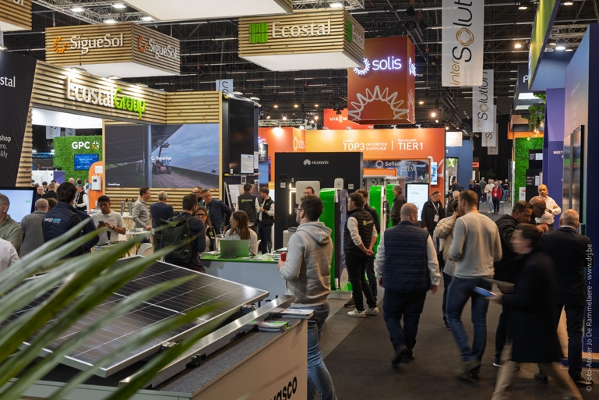

Ghent, 15 January 2026 – With around 100 international exhibitors and 4,486 professional visitors spread over two exhibition days, InterSolution 2026 has once again confirmed its position as the meeting place for the solar energy sector in the Benelux. The 14th edition of the solar trade fair took place on 14 and 15 January at Flanders Expo in Ghent, where market leaders and innovative newcomers – from Belgium, the Netherlands and Germany, as well as France, the United Kingdom, Luxembourg, Austria and China – presented their latest technologies, services and turnkey solutions across a 10,000 m² exhibition floor. The extensive content programme of the InterSolutionSummit also attracted strong interest.

Since 2009, InterSolution has positioned itself as the substantive kick-off of the trade fair year for solar energy professionals from the Benelux. In 2026 as well, the fair once again proved to be a relevant platform in a sector undergoing rapid transformation. The exhibition offered a representative overview of the latest developments in solar panels, inverters, battery storage, energy management systems (EMS), e-mobility, heat pumps, plug-and-play solutions and circular applications.

Focus on system integration and large-scale projects
The energy transition is accelerating, and this was clearly visible on the exhibition floor. An increasing number of exhibitors showcased integrated energy systems combining solar energy with storage, electric mobility and smart control. Energy Management Systems played a central role in this context. In addition, there was a notable focus this year on large-scale solar projects, such as industrial rooftops, solar parks and energy hubs with battery storage. Topics including grid congestion, scalable storage solutions and Power Purchase Agreements (PPAs) were discussed extensively and attracted developers, investors, EPCs and large industrial consumers.

Strong international line-up
The exhibition floor reflected the technological dynamism of the sector. Exhibitors included both established international players and innovative newcomers. Companies such as Viessmann, BelgaSolar, Sungrow, Fronius, BayWa r.e., GoodWe, Rexel, Vandervalk Solar Systems, Krannich, Cebeo, Libra Energy, Solax, Solis, Wattkraft, Conduct and many others were present. This mix of experience and innovation resulted in a content-rich and future-oriented edition of the fair.

InterSolutionSummit as a content compass
The InterSolutionSummit 2026 once again formed a key content anchor of the fair. Over two days, the Summit combined Previews, Labs and Talks, with a strong focus on both technological innovation and strategic reflection.
During the Previews, visitors received a concise overview of new product releases and solutions, while the Labs provided in-depth insights into current technical and operational challenges, such as AI-driven energy optimisation, fire safety, commercial & industrial battery systems, and circular models for solar panels and batteries.
The Talks offered space for debate and interpretation. Sessions on new European obligations regarding solar installations on commercial buildings, the impact of negative electricity prices on large-scale solar parks, and the growing role of flexibility and EMS integration attracted particular interest. Federations, research institutions and market players engaged in dialogue on the future direction of the sector.

Networking platform for the Benelux
In addition to technology and knowledge, networking remained a core function of InterSolution. With visitors from Belgium and the Netherlands, supplemented by professionals from Germany, the United Kingdom, China, Russia, the US, etc., the fair once again served as an important international networking platform. Contacts made during the B2B trade fair often form the basis for new projects and long-term collaborations.

Looking ahead
With this successful 14th edition, InterSolution confirms its role as a fixture within the solar energy sector. The organisation is already looking ahead to the next edition and continues to focus on content, quality and relevance in a rapidly changing energy market. Interested exhibitors can already register via info@intersolution.be.

More information
For more details about InterSolution and the upcoming edition, visit www.intersolution.be.

Save the date: 15th edition of InterSolution on 27 & 28 January 2027 at Flanders Expo in Ghent (Belgium)

Aftermovie InterSolution 2026: https://youtu.be/L0cQN4tTB54?si=xZRZSmGTDpvMS5G2

*** NOT FOR PUBLICATION ***

Images (photos of 2026 edition) are available for download at www.intersolution.be (Press – Visual material)

For more press information, please contact:
Kurt Peeters, press officer
M +32 (0)474 444 660
press@intersolution.be
Trade fair organisation:
Delfico bv
Maaltebruggestraat 300
9000 Ghent (Belgium)
T +32 (0)9 385 77 19
www.intersolution.be

