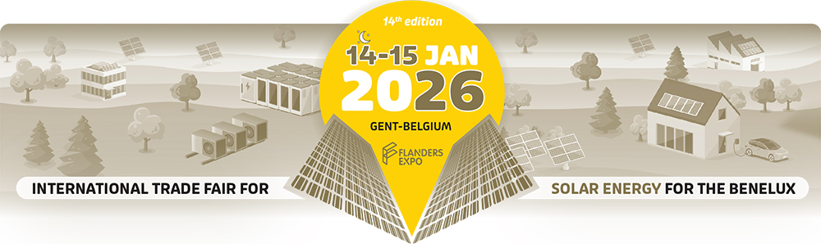
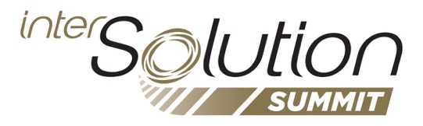

Press release – Ghent, 25 November 2025
InterSolutionSummit 2026: knowledge, innovation and a strong focus on large-scale solar energy
14 & 15 January 2026 – Flanders Expo, Ghent (Belgium)
On 14 and 15 January 2026, InterSolution, the leading solar trade fair for the Benelux, returns to Flanders Expo in Ghent. As in previous years, the fair is entirely dedicated to technological progress, market insights and professional connections within the rapidly evolving solar energy sector. A central role is once again reserved for the InterSolutionSummit, which was successfully launched in 2025 and this year expands into an even more extensive and in-depth knowledge platform.

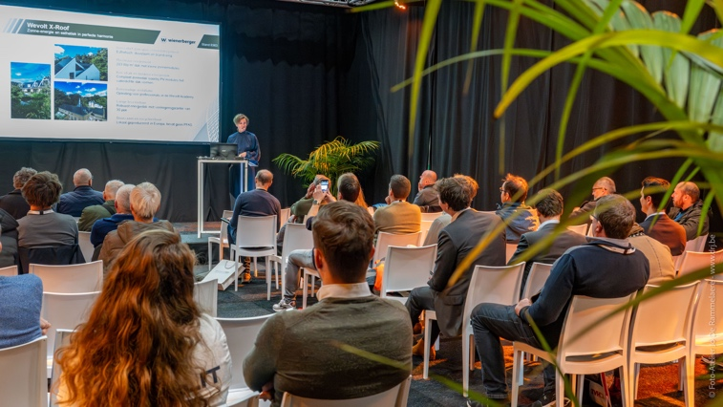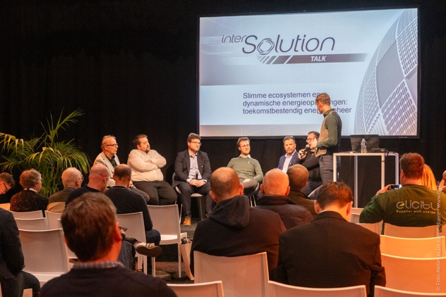
The Summit forms the beating heart of the fair: a place where exhibitors, federations, research institutes, installers, investors and developers come together to discuss today’s and tomorrow’s most important trends and challenges. This edition emphasises the growing importance of large-scale solar projects, battery storage and integrated energy management.
A rich programme full of innovation and practical expertise
Over two days, the Summit combines inspiring panel discussions with hands-on sessions and previews of the latest technologies.
The InterSolutionPreviews offer visitors a clear and concise overview of product launches, mounting innovations, storage technologies, energy-management software and new components by, among others, 2 Solar, Atmoce, Belga Solar, Conduct Technical Solutions, Eniris, FIRN Energy, GPC Europe, Octave.energy, PVX Mounting Systems, Rexel, Solis, Soliseco and Ysebaert. Thanks to alternating NL/EN and NL/FR sessions, the previews are accessible to Belgian, Dutch and international visitors.
The InterSolutionLabs offer further depth. In compact presentations, companies such as Atmoce, Bebat, Belga Solar, Belgian Eco Energy (BEE), Cebeo, Conduct Technical Solutions, Eniris, FIRN Energy, Fronius International, GPC Europe, Libra Energy, Octave.energy, PV Cycle Belgium, Rexel, Sollit, Solis, Soliseco and Vamat demonstrate how they address current technical and operational challenges: fire safety and semi-off-grid solutions, AI-driven energy optimisation, commercial & industrial battery systems, European component innovation, digital tools for installers, circular models for the life cycle of solar panels and batteries, and energy independence in residential and professional contexts.
InterSolutionTalks: guiding a rapidly changing market
Beyond technical depth, the Summit provides strategic reflection. The InterSolutionTalks bring together federations, researchers and market players to explore the most urgent themes.
A highlight is the session on the new European obligations for solar panels on commercial buildings, which will be phased in from 2026. Experts from EV Belgium, ODE/PV-Vlaanderen and SolarPower Europe will outline the legal, technical and economic impact and explain how companies can prepare.
Another English-language panel examines how negative power prices, flexibility and large-scale battery storage are reshaping the business model of large solar parks. The increasing need for smart control, PPA structures and market integration is central here, with contributions from Edora and SolarPower Europe.
Energy management and EMS integration also play a key role. Visitors will discover how solar energy, storage, e-mobility and heating solutions increasingly merge into a single intelligent energy system. Speakers include EnergyVille / KU Leuven, EV Belgium and ODE/PV-Vlaanderen.
Together, these talks help steer a sector that is changing faster than ever, and in which large-scale applications are becoming essential for grid stability and the profitability of solar projects.
Provisional programme now available
The complete provisional programme of the InterSolutionSummit – including all Previews, Labs and Talks – is available today at www.intersolution.be

About InterSolution 2026
InterSolution once again welcomes around 100 exhibitors from across the Benelux and beyond. Installers, EPCs, developers, building managers, retailers and investors will discover the latest developments in solar panels, mounting, storage, EMS software, dynamic energy solutions and EV charging infrastructure. With the strengthened InterSolutionSummit, the fair creates a content-driven hub that helps visitors make strategic decisions in a market undergoing full transition.
Use the invitation code XXX to visit the two-day fair free of charge.
Practical information
InterSolution – Solar trade fair for the Benelux
- Wednesday 14 January 2026: 9:30 – 20:00
- Thursday 15 January 2026: 9:30 – 18:00
Flanders Expo, Ghent (Hall 8) – Maaltekouter 1, 9051 Ghent, Belgium
Ample parking and easily accessible by public transport. Only 25 km from the Dutch border. Accommodation available nearby.

NOT FOR PUBLICATION

Please request an invitation code prior to publication, which you can then mention in your article. This way your readers can register with a unique code, allowing them to visit the fair free of charge. Simply request your code by e-mailing: press@intersolution.be

Visual material (logo and photos from the 2025 fair) can be downloaded at www.intersolution.be (via Press – Visual material)

Press contact:
Kurt Peeters
M +32 (0)474 444 660
press@intersolution.be
Trade fair organiser:
Delfico bv
Maaltebruggestraat 300
9000 Ghent (Belgium)
Tel.: + 32 (0)9 385 77 19
www.intersolution.be

