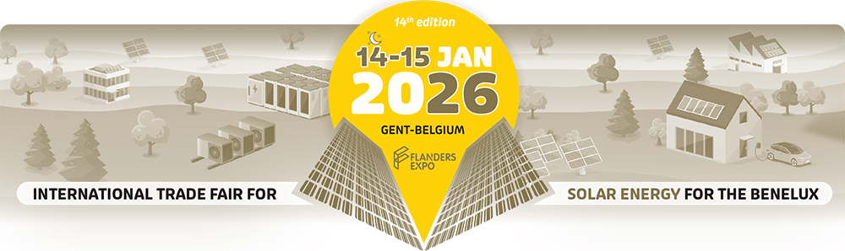

**Press release – Ghent, 1 September 2025**

**InterSolution 2026, the leading trade fair for solar energy for 14 years**

Discover everything about solar power and smart integration

*14 & 15 January 2026 – Flanders Expo, Ghent (Belgium)*

**Curious about what tomorrow's solar energy market will look like? Then visit the 14th edition of InterSolution, the number one solar trade fair for the Benelux, on 14 and 15 January 2026. In Hall 8 of Flanders Expo in Ghent, the most important players from home and abroad will present their latest technologies, services and total solutions on a clearly laid out exhibition floor covering 10,000 m².**

**A professional platform in a rapidly evolving sector**

InterSolution is the ideal start to the trade fair year for anyone active in solar energy. As a leading networking and trade fair, InterSolution offers a platform for professionals looking for total solutions and new opportunities in a rapidly changing market. It is the place where high-quality leads are generated, knowledge is shared, strategic partnerships are formed, and innovations are showcased.

**Strong line-up of exhibitors**

The fair brings together a wide range of international exhibitors – market leaders and innovative newcomers alike. Interest from manufacturers and wholesalers remains high. Around 100 companies are expected to participate again this year. Confirmed participants include big names such as **Viessmann, BelgaSolar, Sungrow, Bee, JA Solar, GoodWe, Rexel, BayWa r.e., Ecostal, Vandervalk Solar Systems, Euro-Index, Fronius, GPC Europe, Krannich, Cebeo, Libra Energy, SolarToday, Solax, Allimex, Solis, Wattkraft** and many others. The complete list of exhibitors will be available from November at [www.intersolution.be](http://www.intersolution.be). Interested exhibitors can register via [info@intersolution.be](mailto:info@intersolution.be).

**Focus themes for 2026: from solar panels to system integration**

At InterSolution, visitors will discover the latest developments in areas such as:

• Solar panels and inverters

• Battery storage and smart energy storage

• E-mobility and charging solutions for electric vehicles

• Plug & play solar solutions

• Energy management via software and EMS (Energy Management Systems)

• Heat pumps and energy saving

• Recycling and circular applications

The energy transition is accelerating, and with it, the way we generate, store and consume energy is also changing. **System integration** plays a key role in this evolution: technologies such as energy storage, electric mobility and heat pumps are increasingly being combined into smart total solutions. Energy Management Systems (EMS) are central to this – and this will also be clearly visible on the exhibition floor.  
  
InterSolution continues to focus on **larger solar projects**, including solar parks, industrial roofs and energy hubs with battery storage. Within this segment, extra attention will be paid this year to themes such as grid congestion, scalable storage, and investment models via Power Purchase Agreements (PPAs). The exhibition therefore also appeals to **developers, investors, EPCs and large industrial consumers** – parties that are active in strategic energy projects on a larger scale.

**Product launches, demos and seminars**

Visitors to InterSolution 2026 can immerse themselves in a rich offering of inspiring seminars, innovative product launches and practical demonstrations. Once again, dozens of presentations and panel discussions will take place during the **InterSolutionSummit**, in which experts will share their views on current topics and future-oriented solutions – ranging from installation and system integration to large-scale applications, investment structures and energy management at project level. The full content programme will be announced on the website in December.

**Networking with impact**

In addition to discovering products and innovations, InterSolution is an important networking opportunity for professionals from the Benelux. The contacts made here, across national borders, often form the basis for new projects or long-term collaborations.

**Ticket registration open**

InterSolution 2026 will take place on 14 and 15 January at Flanders Expo in Ghent (Belgium) and is exclusively accessible to professionals from the solar energy sector: installers, contractors, electricians, engineering firms, architects, government agencies, distributors and sustainable energy consultants. Use the invitation code **XXX** to visit the two-day fair for free (or scan the QR code on the advertisements). On Wednesday, the fair is open until 8 p.m., giving you plenty of time to discover everything. More information about the programme and tickets can be found at [www.intersolution.be](http://www.intersolution.be).

**Practical information**

InterSolution – Solar trade fair for the Benelux

Wednesday 14 January 2026: 9:30 a.m. – 8 p.m.

Thursday 15 January 2026: 9:30 a.m. – 6 p.m.

Flanders Expo, Ghent (Hall 8) – Maaltekouter 1, 9051 Ghent, Belgium

*Ample parking and easily accessible by public transport. Accommodation available nearby.*

**Watch the video of InterSolution 2025:** <https://youtu.be/s2lF0cr1YOQ?si=uon6Y5kLVgb3KdMR>

**NOT FOR PUBLICATION**

**Please request an invitation code prior to publication, which you can then mention in your article.** This way your readers can register with a unique code, allowing them to visit the fair free of charge. Simply request your code by e-mailing: [press@intersolution.be](mailto:press@polyclose.be)

**Visual material** (logo and photos from the 2025 fair) can be downloaded at [www.intersolution.be](http://www.intersolution.be) (via Press – Visual material)

**Press contact:**Kurt Peeters   
M +32 (0)474 444 660  
[press@intersolution.be](mailto:press@intersolution.be) **Trade fair organiser:**Delfico bv  
Maaltebruggestraat 300  
9000 Ghent (Belgium)  
Tel.: + 32 (0)9 385 77 19   
[www.intersolution.be](http://www.intersolution.be)