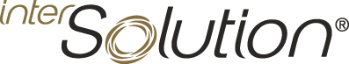 **PRESS INFO: INTERSOLUTION 2025**Ghent (Belgium), January 2025

**InterSolution 2025 confirms its role as the leading platform for the solar industry in Benelux**13th solar trade fair focusing on content and quality

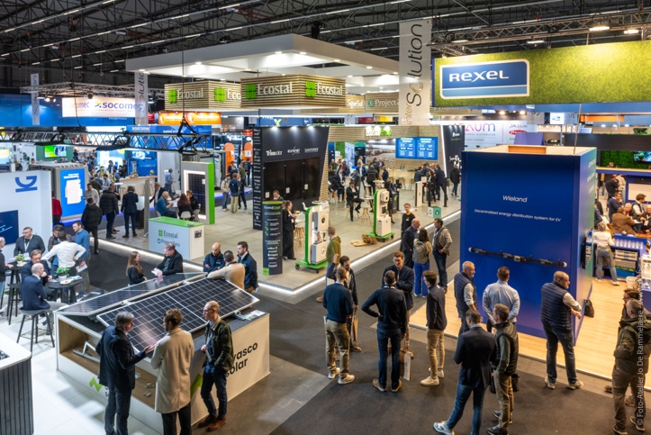

**Ghent, 31 January 2025 – With more than 120 distinguished exhibitors, mainly from Western Europe, and 4,702 visitors, on 29 and 30 January InterSolution 2025 once again reinforced its position as the leading platform for the solar industry in Benelux. In an exhibition hall of no less than 10,000 square metres at Flanders Expo in Ghent, market leaders and innovative newcomers showcased the latest solar energy technologies and solutions. The targeted content sessions of the new InterSolutionSummit that took place on both days of the fair – consisting of Previews, Labs and Talks – likewise attracted a lot of interest.**

It is no secret that market conditions currently present a challenge to the solar industry in the Benelux region. Visitor and exhibitor interest in InterSolution nevertheless remains extremely high. Manufacturers and wholesalers (from countries including Belgium, the Netherlands, Luxembourg, Germany, the UK, Switzerland, Austria, Slovenia, Spain, China…) again offered attendees at this 13th fair a full update on the latest developments in batteries, energy management systems, EV charging, measuring instruments, assembly systems, converters, recycling, solar cells, PV modules and related products.

**A sunny outlook for the future**

The energy transition is gaining momentum, and the way we generate, store and use energy is changing dramatically, as was evident at this well-attended show. Exhibitors presented solutions addressing the growing demand for integrated systems for solar power generation, battery storage, e-mobility and energy management. Given the increasing popularity of solar panels, the need for recycling also figured prominently here.

**Top international brands and innovations**

The exhibition once again reflected the rapid technological advances seen in the sector. Major market players were in attendance, for example SMA Benelux, Belga Solar, GoodWe, Niko, wienerberger, Growatt, Sungrow, Socomec, Van der Valk Solar Systems, SolaX Power and others. Besides many loyal returning exhibitors, numerous new but familiar names also took part this year, including Viessmann, Eaton, JA Solar and Wanit, to name just a few.

"*I would like to thank our many loyal and new exhibitors for their trust and commitment,"* said fair manager Delphine Martens. *"Thanks to their collective enthusiasm, this year’s show was* *once more all about content and quality, and InterSolution has again lived up to its position as the leading solar trade fair for the Benelux market."*

**Introducing: the InterSolutionSummit**

New this year was the InterSolutionSummit, a forum with topical contributions from different exhibitors, trade associations and experts. Featuring product presentations combined with in-depth discussions on the future of the industry, the programme was enthusiastically received by both visitors and exhibitors. Visitors were updated on the key innovations showcased at the fair during the Previews. At the interactive Lab sessions exhibitors displayed solutions developed from their expertise and competences. Lastly there were the Talks: panel discussions and case presentations with experts, looking at current trends and developments in the solar sector. Exploring for example smart ecosystems and dynamic energy solutions, trends and innovations in grid management, circularity and strategies for energy cost management and flexible energy solutions. This initiative highlighted the role of InterSolution as a catalyst for innovation and collaboration.

**An important link in the Benelux market**

With 13% of visitors coming from the Netherlands and the majority from Belgium, InterSolution remains an important networking platform for the Benelux market. The two-day trade fair once again attracted a diverse audience of installers, electricians, contractors, architects and other professionals, who will reap its benefits over the rest of the year. This makes InterSolution the place to acquire knowledge, make contacts and establish new partnerships.

*“The qualitative meetings at our booth confirm the continuation of the green transition in which we will play a crucial role.”* - C. De Bruyn (SMA Benelux)

*“Our first participation was definitely successful! With our stand full of innovative solutions, we attracted a lot of curious eyes and made exciting contacts for the future.”* - K. Huysmans (Viessmann)

*“InterSolution was an ideal forum for us to present our roof-integrated solar energy solutions to a professional audience.”*- S. Merlevede (wienerberger)

**Save the date: InterSolution 2026**

Following this year’s success, the organisers are now looking forward to the next fair, to be held again at Flanders Expo in Ghent on 14 and 15 January 2026. The 14th edition promises to be yet another source of inspiration and innovation. Interested exhibitors can now register via [info@intersolution.be](mailto:info@intersolution.be).

**More information**

For further details about InterSolution and the next fair, visit [www.intersolution.be.](http://www.intersolution.be)

**Make a note in your calendar: 14th InterSolution at Flanders Expo in Ghent (Belgium) on 14 and 15 January 2026**

*🡪 InterSolution 2025 aftermovie:* [*https://youtu.be/s2lF0cr1YOQ*](https://youtu.be/s2lF0cr1YOQ)

**\*\*\* NOT FOR PUBLICATION \*\*\***

**Images** (photos of 2025 edition) are available for download at [www.intersolution.be](http://www.intersolution.be) (go to *Press* – *Visual material*)

**For more press information, please contact:**Kurt Peeters, press officer   
M +32 (0)474 444 660  
[press@intersolution.be](mailto:press@intersolution.be) **Trade fair organisation:**Delfico bv  
Maaltebruggestraat 300  
9000 Ghent (Belgium)  
T +32 (0)9 385 77 19   
[www.intersolution.be](http://www.intersolution.be)