 **PRESS INFO: INTERSOLUTION 2025**Ghent (Belgium), September 2024

**13th InterSolution: the No. 1 solar trade fair for the Benelux   
 on 29 and 30 January 2025**

Major market players represented again –  
International solar innovations of 2025 under one roof

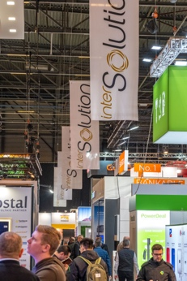 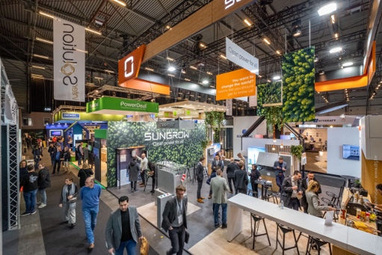 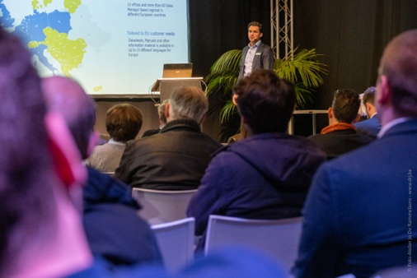

**On 29 and 30 January 2025 the solar industry will once again gather at Flanders Expo in Ghent (Belgium) for the 13th edition of InterSolution. The leading networking and trade fair for solar energy for the Benelux market (since 2009) offers professionals the ultimate opportunity to discover the latest solar innovations. Clearly arranged in one spacious hall with an exhibition area of 10,000 m2, industry leaders will present their products and services of 2025 to the market.**

Despite challenging market conditions, the level of exhibitor interest in this Benelux trade fair remains extremely high. Some 130 companies from all over the world are expected to attend, showcasing their solar panels, solar cells, inverters, batteries, charging solutions, assembly systems and related products. There will also be ample networking opportunities and an extensive content programme with a variety of themes. Entry is reserved for trade visitors and is free of charge with online registration. During late-night opening on the Wednesday, the fair will be open until 8 p.m.

**Solar energy: the driving force behind sustainability**

Solar energy will undoubtedly continue to play a vital role in making our energy supply more sustainable in 2024 and 2025. The roll-out of solar panels within industry is on the rise. The residential market also offers major potential, as two in three homes in Flanders and the Netherlands are still without solar panels. The number of electric vehicles is growing fast and the battery storage sector is likewise expanding. Solar energy is increasingly being incorporated in smart energy systems, combined with other sustainable technologies. Solar players are constantly innovating so as to help individuals, businesses and governments with the energy transition and with achieving climate targets. InterSolution offers professionals the chance to keep up to date with all these market developments.

**A taste of the innovations for 2025**

As InterSolution is the first fair of the new year for most participants, visitors will get a good idea of the innovations in store for the market of solar panels, inverters, batteries, charging stations, assembly systems, control technologies, software and monitoring in 2025. The two-day trade fair is thus a source of valuable contacts and opportunities for both exhibitors and visitors such as electricians, installers, contractors, roofers, plumbers and architects: they stand to reap the benefits over the rest of the year.

In addition to presenting the latest products and technologies, InterSolution 2025 offers an extensive content programme on various themes, explaining innovations and applications. The full programme will be available on the website from December.

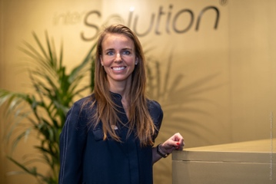As exhibition manager Delphine Martens commented, *"It’s a real pleasure that we can continue to count on the enthusiasm of so many loyal exhibitors over all these years. In line with tradition, many exhibits will be unveiled for the very first time, and the fair is the ultimate chance to make lots of new contacts, exchange knowledge and develop business opportunities in a relatively short space of time. Quality remains paramount, with the event offering strong content for visitors and premium leads for exhibitors."*

**Revamped website: InterSolution.be**

InterSolution has now a renewed website. Besides a fresh look to the site, it will now be even easier to find information about participating exhibitors: [www.intersolution.be](http://www.intersolution.be).

**InterSolution in a nutshell**

InterSolution is a “solar-wide” trade fair that offers a complete 360° overview of innovations in solar-related applications: batteries, wiring, fixation systems, charging systems, measurement and control devices, monitoring systems, assembly systems, inverters, production equipment, PV modules, regulators, software, trackers, heat pumps, solar boilers, solar cells, solar collectors and solar panels.

With over 70% of stand space already taken, exhibitors will include major players such as SMA, Wienerberger, Niko, Sungrow, Duracell, SolaX, Eaton, GoodWe, Rexel, SolarEdge, BayWa r.e., Ecostal… and many others. The full exhibitor list can be found on the website from November.

InterSolution is a must for professionals from the solar industry in Belgium and the Netherlands, such as electricians, manufacturers, contractors, installers, engineering firms, roofers, plumbers, architects, distributors, heating engineers, public authorities and other specialists from the solar sector employed in consultancy, renewable energy or swimming pools.

InterSolution is being held at Flanders Expo in Ghent, a location that is easily accessible from all over Belgium and barely 25 km from the Dutch border. Various accommodation options are also available nearby.

**Practical information**

* **Location:** Flanders Expo Ghent (Belgium) – Hall 8
* **Dates:** Wednesday 29 and Thursday 30 January 2025
* **Opening times:** Wednesday from 9.30 a.m. to 8.00 p.m. (late-night opening), Thursday from 9.30 a.m. to 6.00 p.m.
* **Free admission for trade:** Register in advance at [www.intersolution.be](http://www.intersolution.be) with invitation code
* **List of exhibitors:** Available from November at [www.intersolution.be](http://www.intersolution.be)
* **Registration for exhibitors:** [info@intersolution.be](mailto:info@intersolution.be)

**Watch the video from InterSolution 2024:** <https://youtu.be/CLJotbai8nQ?si=bTlNWaXi38h_tsQI>

**\*\*\* NOT FOR PUBLICATION \*\*\***

**Please request an invitation code prior to publication, which you can then mention in your article.** This way your readers can register with a unique code, allowing them to visit the fair free of charge. Simply request your code by e-mailing: [press@intersolution.be](mailto:press@polyclose.be)

**Visual material** (logo and photos from the 2024 fair) can be downloaded at [www.intersolution.be](http://www.intersolution.be) (via *Press* > *Visual material*)

**For more press information, please contact:**Kurt Peeters, InterSolution Press Manager  
M +32 (0)474 444 660  
[press@intersolution.be](mailto:press@intersolution.be) **Trade fair organisers:**Delfico bv  
Maaltebruggestraat 300  
9000 Ghent (Belgium)  
Tel.: + 32 (0)9 385 77 19   
[www.intersolution.be](http://www.intersolution.be)